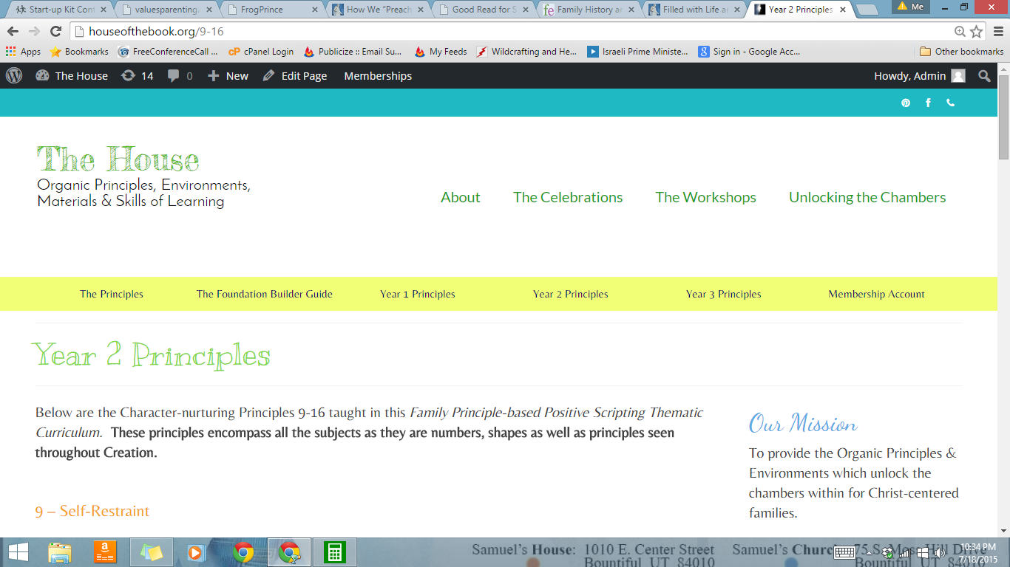

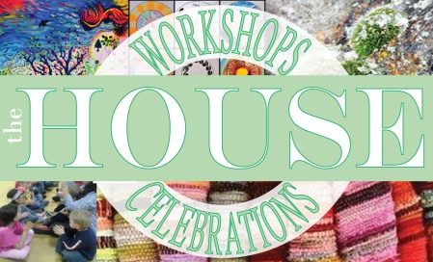
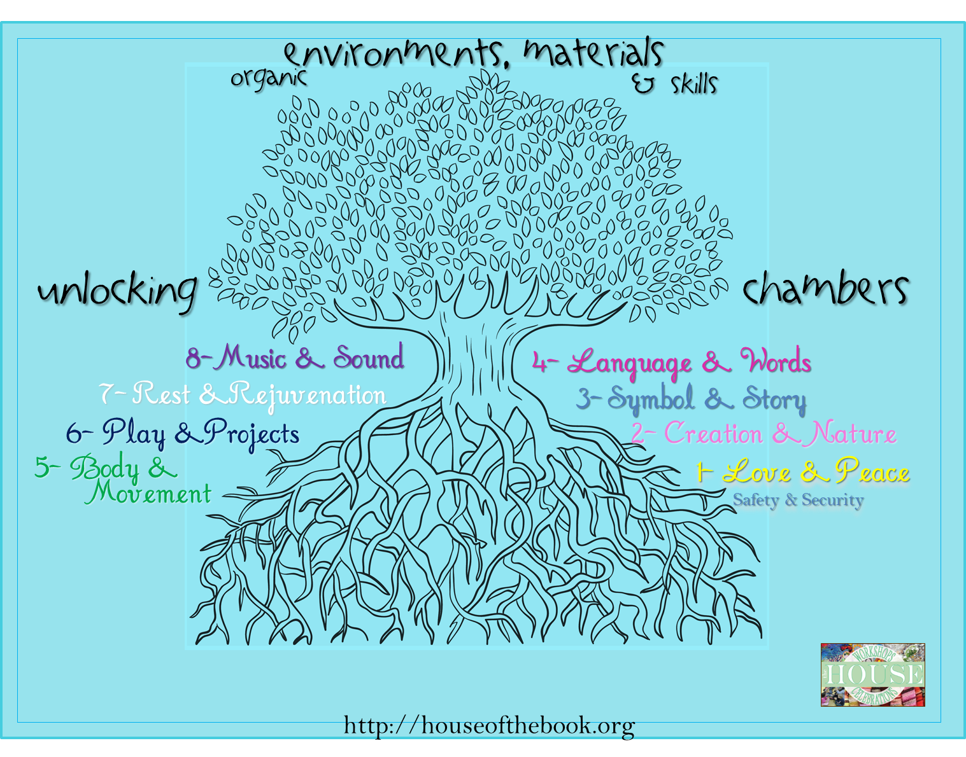
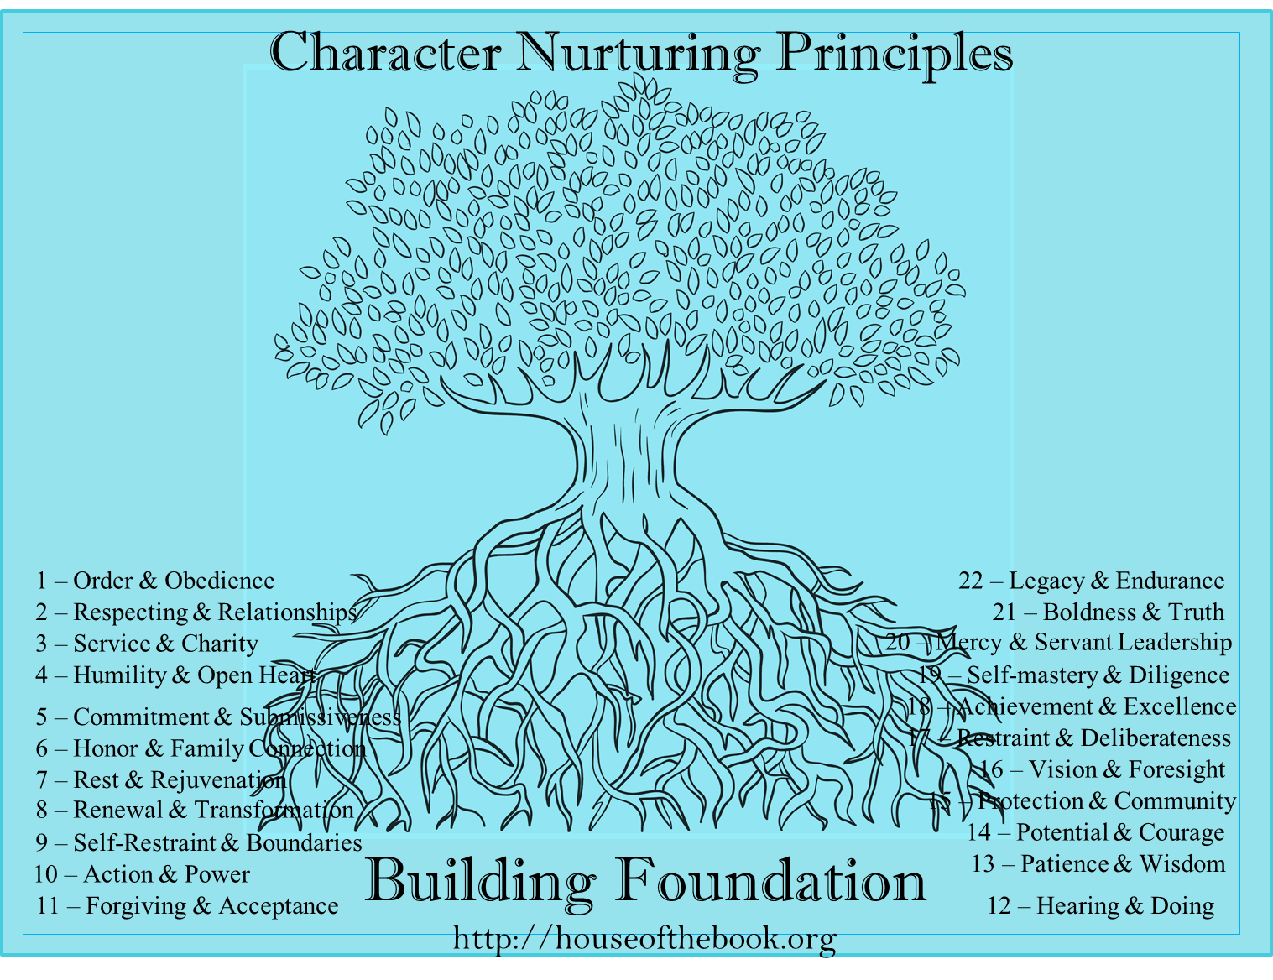
The Foundation Builder Guide
“The Principles
of Creation”
&
“The Organic
Environments
& Materials”
Building Foundation
Unlocking Genius
through

This pamphlet contains:

Character Building Habits (Charts)
Principles – Order, Work, Structure, Accountability, Return and Report, Discipline, Observe, Follow

- Morning Chart
- Reminder Chart
- Skills Practice Chart
- Blank Page 6 & 8 Daily Plans
- Practice Time Bank Incentive Chart
These are a way to create a Time Bank where all the time a child puts into their learning, they would have free-time or other rewards.


Morning Chart

Prayer M T W Th F S S
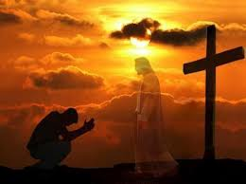

Stewardships M T W Th F S S
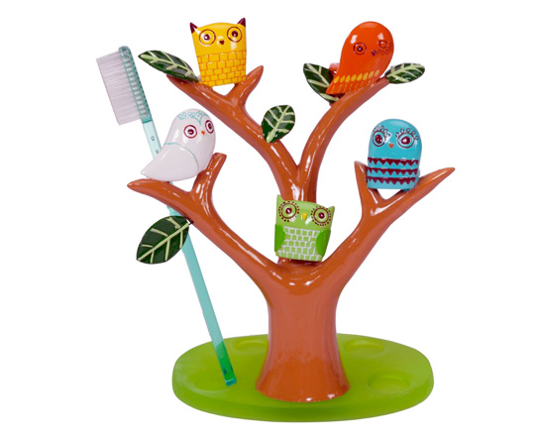
Brush teeth

Make Bed M T W Th F S S
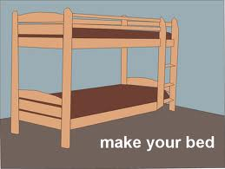

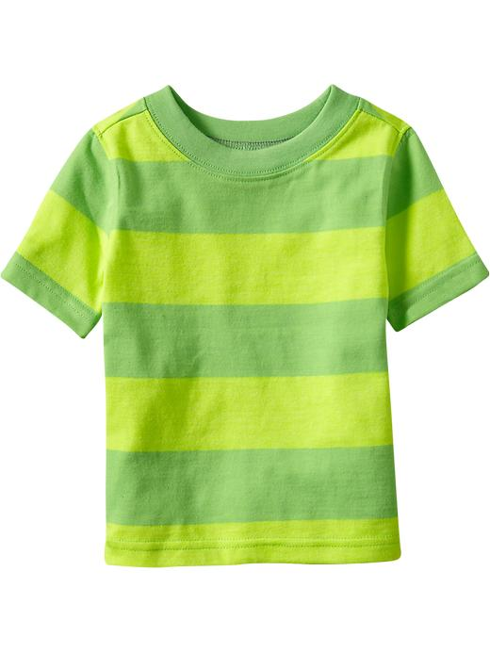
Put on & Put away M T W Th F S S
clothes
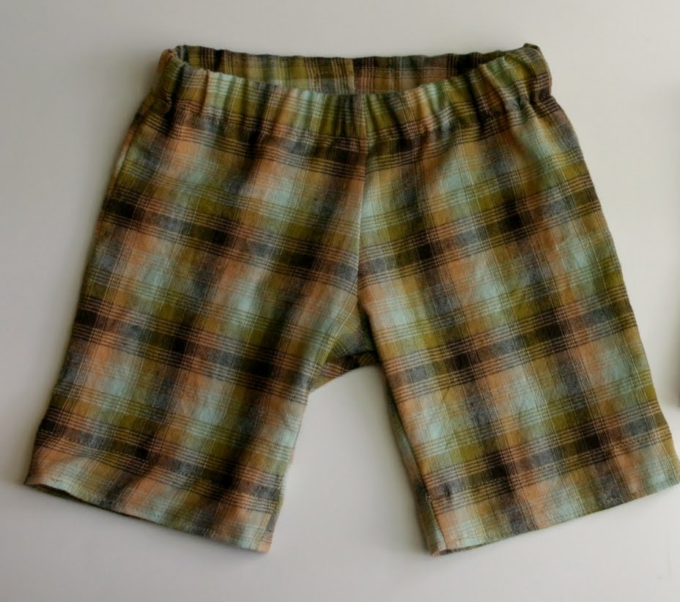

Help with ____ M T W Th F S S

Breakfast M T W Th F S S
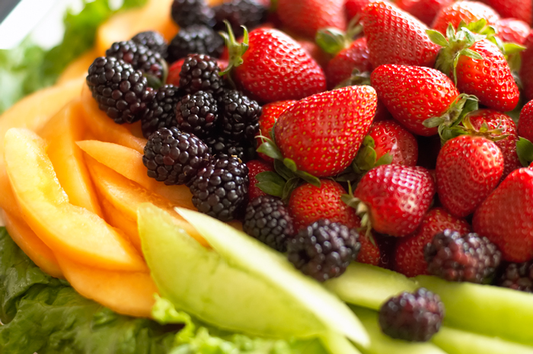


Reminder Chart

Stewardships M T W Th F S S
Body
(Brush, Shower, Bed, Clothes,Room)
Mind (Affirmations)
Spirit (Prayer)
Emotion
(Flag Poll, Write out, Release it)
Family
- Natural Yeast
- Make Natural Yeast for Breakfast as needed
- Make Dinner on Wednesday

Skills M T W Th F S S
Reading
Music
Phonics
Arithmetic
“Faith to God”

Skills Practice Chart
Faith in God M T W Th F S S
Prayer
Scriptures
Journal

Stewardships M T W Th F S S
Exercise
Brush
Shower
Sweep
Chickens
Dog
Weeding
Jobs
Service

Skills M T W Th F S S
Reading
Handwriting
Phonics
Arithmetic
Scouts/F.I.G.
Practice

Name: ___________________________________ Date: ________________________
Name: ___________________________________ Date: ________________________

Name: ___________________________________ Date: ________________________

Name: ___________________________________ Date: ________________________

Practice Time Bank
Music – 5 | Arithmetic – 5 | Handwriting – 5 | Reading - 5 | Projects - 5

Date Practice/ Projects +/- =
/
/
/
/
/
/
/
/
/
/
/
/
/
/
/
/
/
/

